**4. Reactjs-HOL**

**Step 1.** Create a new react app named blogapp using command

“**npx create-react-app blogapp”**



**Step 2.** Create a new file named as **Post.js** in **src folder** with following properties

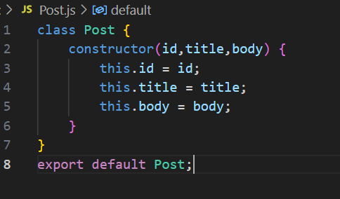

**Step 3.** Create a new class based component named as **Posts** inside **Posts.js** file

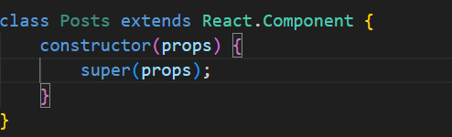

**Step 4.** Create a new method in component with the name as **loadPosts()** which will be responsible for using Fetch API and assign it to the component state created earlier. To get the posts use the url (<https://jsonplaceholder.typicode.com/posts>)

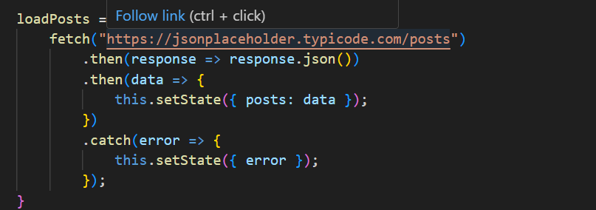

**Step 5.** Implement the **componentDidMount()** hook to make calls to **loadPosts()** which will fetch the posts

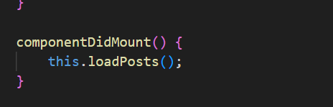

**Step 6.** Implement render which will render the loaded data

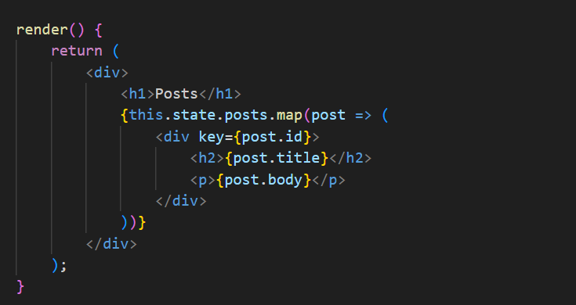

**Step 7.** Add the Post component to app.js file

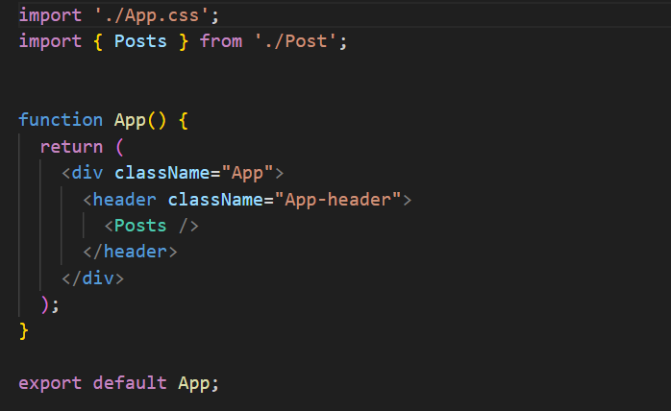

**Step 8**. Run the server using the **“npm start”** command



Output:- Output should look like this   
